1. **How to calculate a difference between two dates?**

Answer: Difference between to valid dates can be found simply by subtracting the dates, then divide them into the output format we expect. The output we get out of this would be in days, to convert it to year we divide it with 365.25 (.25 to account the leap year), further to know difference in month we need to divide it with 30 days. By multiplying the output with 24 will convert the difference into hours. Or Use Yearfrac(), it gives exact difference in years, where months and days are displayed in decimals. For ex, 1 Jan 2020 minus 30 June 2021, will be 1.5 years. And hidden fundtion =Datedif() can also be used to get difference in desired format, years, month,dates.

1. **Name some Text Functions?**

Answer: CONCATENATE( ) – used to join several text strings to one string.

TEXT( ) – Converting a value into text formatting.

PROPER ( ) – Arranging the characters in proper way.

LEFT ( ) – Returns the specified number of characters from the starting character.

1. **Which function would you use to get the current date and time in Excel?**

Answer: The following functions can be used:

TODAY() – This function takes no argument and would return the current date value.

NOW() – This function takes no argument and would return the current date and time value. Remember that that date and time are stored as numbers in Excel. So that you can perform operations such as addition/subtraction with these dates.

1. **What is the way to get the week number of the year for a given date?**

Answer: We can use the =WEEKNUM() function to know the week number for any given date.

1. **We have a text string, how to identify the total characters in the cell?**

Answer: To know the length of a string present a cell we must use the =LEN(string) which will show the count of characters present in the given string. This includes all the spaces and special character present in the cell. String is the ‘text’ written in the cell, it can be a letter, word or sentence/s.

1. You have a worksheet with the year in column A, the month in column B, and the day in column C. All fields contain numbers. What function would you use to create the date column in D?
   1. DATEVALUE
   2. CONCATENATE
   3. TEXTJOIN
   4. **DATE**
2. The default header for a worksheet is?
   1. Your name
   2. The date and time
   3. **None**
   4. The sheet tab name
3. In MS-Excel which functions will calculate the number of workdays between 6/9/2013 and 8/12/2013
   1. Workday
   2. Date
   3. **Networkday**
   4. Weekday
4. If you start a date series by dragging down the fill handle of a single cell that contains the date 12/1/19, what will you get?
   1. **a series of consecutive days following the initial date**
   2. a series of days exactly one month apart
   3. a series of days identical to the initial date
   4. **a series of days exactly one year apart**
5. The NOW() function returns the current date and time as 43740.665218. Which part of this value indicates the time?
   1. 6652
   2. 43740.665218
   3. 43740
   4. **665218**
6. Monthly revenues of 2019 are entered in B2:M2, as shown below, To get year-to-date running total revenues, what formula should you enter in B3 and autofill through M3?  
   [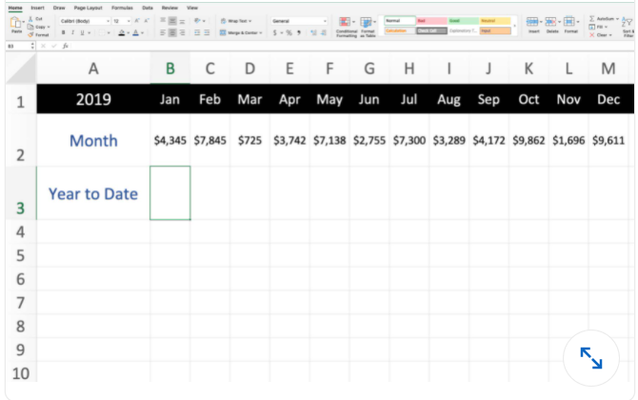](https://github.com/Ebazhanov/linkedin-skill-assessments-quizzes/blob/main/microsoft-excel/images/Q71.png?raw=png)
   1. =SUMIF($B$2:$M$2,"COLUMN($B$2:$M$2)<=COLUMN())")
   2. =SUM($B2:B2)
   3. **=SUM(OFFSET($A1,0,0,1,COLUMN()))**
   4. =B2+B3
7. . In the worksheet below, what do the symbols in rows 4, 6, 7, and 11 indicate?  
   [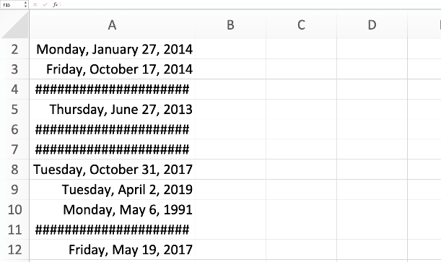](https://github.com/Ebazhanov/linkedin-skill-assessments-quizzes/blob/main/microsoft-excel/images/Q101.png?raw=png)
   1. The dates are erroneous, such as October 39, 2015.
   2. **The columns aren't wide enough to show the full date.**
   3. The time are incorrectly formatted as dates.
   4. The text is incorrectly formatted as dates.
8. Which function returns the leftmost five characters in cell A1?
   1. =FIND(A1,1,5)
   2. =SEARCH(A1,5)
   3. **=LEFT(A1,5)**
   4. =A1-RIGHT(A1,LEN(A1)-5)
9. Q47. Which function returns TRUE if cell A1 contains a text value?
   1. =ISALPHA(A1)
   2. =ISCHAR(A1)
   3. =ISSTRING(A1)
   4. **=ISTEXT(A1)**
10. You have a column of dog breeds that are in all capital letters. What function would you use to convert those dog breeds so that only the first letter of each word is capitalized?
    1. Sentence
    2. Upper
    3. Titlecase
    4. **Proper**
11. You want to remove the unprintable characters and unnecessary spaces from column A. What formula would you put into cell B2 to copy down to the rest of the column?  
    [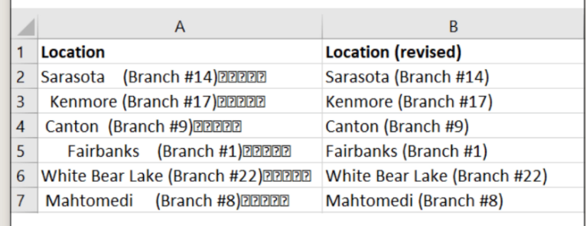](https://github.com/Ebazhanov/linkedin-skill-assessments-quizzes/blob/main/microsoft-excel/images/Q1233.png?raw=png)
    1. ERROR.TYPE(A2)
    2. **=CLEAN(TRIM(A2))**
    3. =CHOOSE(A2)
    4. =TRIM(A2)
12. . Which is not a way to edit a formula in a cell?
    1. Press F2.
    2. Select the cell and then click in the formula bar.
    3. Double-click the cell
    4. **Right-click the cell and select Edit**
13. . The last two digits of the Representative ID Number is the Office ID. Which function, when entered into cell B2 and then dragged to cell B6, returns the Office ID for each representative?  
    [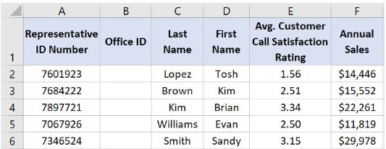](https://user-images.githubusercontent.com/80069786/184557060-2164d8b6-37ae-41d3-9525-31e88065fbdc.jpeg)
    1. =TRIM(A2,2)
    2. =LEFT(A2,2)
    3. **=RIGHT(A2,2)**
    4. =MID(A2,2)
14. If you begin typing an entry into a cell and then realize that you don′t want your entry to be placed into a cell, you:
    1. Press the Erase key
    2. **Press Esc**
    3. Press the Enter button
    4. Press the Edit Formula button
15. . What feature can you use to populate B2:B7 with the number from each sentence in A2:A7?  
    [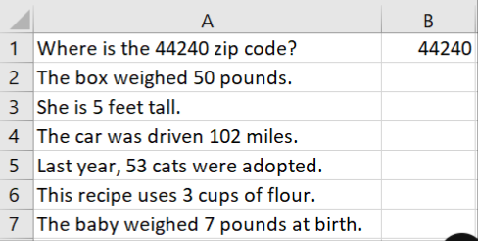](https://user-images.githubusercontent.com/93790398/199109832-18774a59-e00b-4fc1-b798-57a28af96668.png)
    1. No Excel feature can accomplish this; this is possible only using formulas.
    2. **Flash Fill**
    3. Merge cells
    4. Text to columns